**Question 34 [from 2016 Sem I paper WATP] (10 marks)**

1. The nervous system has several different subdivisions which have quite specific functions. Using the table below, state one functional difference between the following parts of the nervous system.

(3 marks)

|  |  |
| --- | --- |
| **Two systems to compare** | **Main difference** |
| Afferent division vs efferent division of the peripheral nervous system |  |
| Central nervous system compared to the peripheral nervous system |  |
| Somatic sensory nervous system compared to the visceral sensory nervous system |  |

The diagram below is of the human brain.

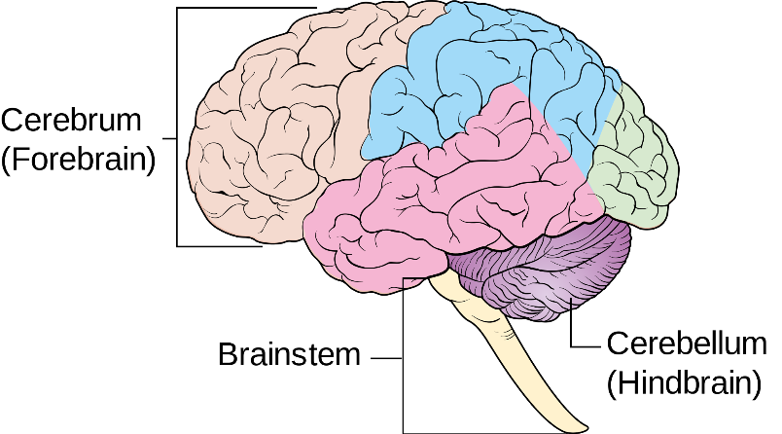

1. On the diagram, label the following areas: (2 marks)
2. the occipital lobe.
3. the medulla oblongata.

d) The human brain is divided up into several sections, each with its own set of specific functions. Complete the table below by summarising ONE function of each area shown. (3 marks)

|  |  |
| --- | --- |
| **Structure** | **Function** |
| Cerebral Cortex |  |
| Hypothalamus |  |
| Medulla oblongata |  |

1. During a mining accident, a man received substantial damage to his cerebellum when a metal pipe hit him from behind.

Describe two symptoms the man might experience as a result of this damage. (2 marks)

___________________________________________________________________________________________________________________________________________________________________________________________________________________________________________________________________________________________________________________________________________________________________________________________________________